

**Program: ESE 4009**

**INSTRUCTOR:** Prof**.** Mike Aleshams

# Group# 7

|  |  |  |
| --- | --- | --- |
| **Student Name** | **Student ID** | **Signature** |
| Amandeep Kaur | 748434 | Amandeep Kaur |
| Shweta Gulati | 747925 | Shweta Gulati |
| Ronakkumar Sharma | 747019 | Ronakkumar Sharma |

*\*By signing above you attest that you have contributed to this submission and confirm that all work you have contributed to this submission is your own work. Any suspicion of copying or plagiarism in this work will result in an investigation of Academic Misconduct and may result in a “0” on the work, an “F” in the course, or possibly more severe penalties.*

**Final Draft**

**Project Title:** IOT based Smart wearable safety gadget

**Description of the latest similar system:**

This is a small device which a person can easily wear as a band .Whenever the person feels unsafe or there is any emergency situation ,the person presses the panic button .Once this button is pressed the device gets activated .Through GPS ,the location of the person is found out and a link of that location is created .Then through GSM, a message and a ring is sent to the preregistered contacts.The message indicates that the person needs help and the link of location of the device user .Alarm buzzer also gets activated to alert the people nearby.

In case the output of the ADXL and Pulse Rate Sensor meet the threshold value ,then also device starts working automatically .The pulse rate sensor gives information about the beats per minute .And usually ,the threshold value is set to 120 beats per minute .While the ADXL sensor is related to the posture of body.

Well as through Ubidots IOT Platform, the live location of the person can be tracked anytime which is very helpful .

**Limitations**

1. In this system, there is no provision for the picture of culprit because the image is very important as it serves as proof and it would be very helpful to save the crimes further.

2. As the the posture of body can be changed due to many reasons so the use of ADXL sensor is not so efficient here.

3.Many microcontrollers are there which have cost less than Raspberry Pi and they are efficient for this system. So, to make the system more cost effective these can be used.

4.Also as it is a wearable device, so weight of the device should be as less as possible. So, lighter microcontroller should be used.

**Final solution:**

**Block Diagram**

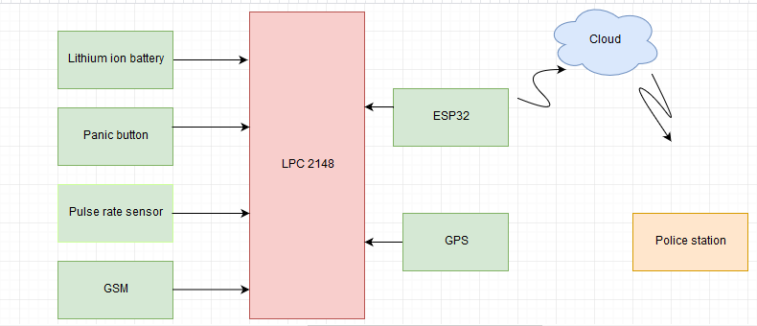

**Features**

* **An additional feature of this system is a camera module that is used for capturing the pictures of the related situation, location, and attacker. Moreover, Cloud is utilized for the storage of such pictures. These images can be used by police for further investigation purposes as they can compare such images with the government record. Apart from this, police can easily search the culprit, and chances of such practices will be reduced.**
* Lithium ion battery is used for power management.
* The system will become cost effective.

**Hardware and Software Requirement**

**Hardware requirement:**

* LPC 2148
* GSM module
* GPS
* Pulse rate sensor
* ESP32(camera and WiFi)
* Panic button
* Lithium ion battery

**Software requirement:**

* Micro vision Keil
* Embedded C
* RTOS is a processing feature of LPC
* Express PCB software-For schematic Design
* Blynk for cloud services

**Features:**

* Peripherals used: GPS ,GSM ,Pulse Rate sensor,Button,ESP32(Camera and WiFi),Lithium Ion Battery.
* UART will be used .
* Preemptive approach will be used.

**Milestone:**

|  |  |  |  |
| --- | --- | --- | --- |
| **Task Number** | **Name of task** | **Name of student** | **Deadline** |
| 1. | Order and analysis of components | Shweta | June 21,2020 |
| **2.** | Schematic design | Amandeep Kaur | June 28,2020 |
| **3.** | Imaging Free RTOS in LPC2148 | Ronak | June 5,2020 |
| **4.** | Interfacing panic button with LPC2148 | Amandeep Kaur | July 12,2020 |
| **5.** | Interfacing pulse rate sensor with LPC2148 | Shweta | July 19,2020 |
| **6.** | Interfacing GSM, GPS with LPC2148 | Ronak | July 26,2020 |
| **7.** | Interfacing ESP32-Cam with LPC2148 | Amandeep Kaur | August 2,2020 |
| **8.** | Interfacing with Cloud services | Shweta | August 9,2020 |
| **9.** | Final testing | Ronak | August 16,2020 |

**References:**

* Tejonidhi.M.R.,Dyana. M.K.Aishwarya, Nagamma.H., Chaithara.K.S. (2019),IOT based smart secuirty gadget for women’s safety, International Conference on Advance in Information Technology.

<https://ieeexplore.ieee.org/document/8987242>

* Badli.S., Jathar.J., Tamble.T., Singhani.S.(2020).Women’s safety using IOT.International Reseach Journal of Engineering and Technology (IRJET).

<https://www.irjet.net/archives/V7/i2/IRJET-V7I2618.pdf>

* Chaudhari.A.,Patel.J., Savla.K.,Shetty.A., Shah.V.(2019).Women’s Safety Band Using IoT.lecture Notes on Data Engineering and Communications Technologies.

<https://link.springer.com/chapter/10.1007/978-981-15-1002-1_50>

**Instructor’s Remarks:**